
THE ROYAL BRITISH LEGION
Greater London District
NEWSLETTER
‘We are not retreating - we are advancing in another direction.’
(Douglas MacArthur)
POPPY APPEAL AS 7th October 2011
POPPY APPEAL TOTAL: £36,599,672.87
METROPOLITAN TOTAL: £ 3,677,336.39

GREATER LONDON DISTRICT
I understand this has been a difficult period and change has happened rather swiftly, however with the start of a new District it will require support for the Legion and London to be a success.
As we are entering the busiest time of Legion activities, please note that Branch Accounts and MS1 have to be sent to either Louis Cecile or Fiona Humphries at Haig House, 199 Borough High Street, London SE1 1AA.
All queries, information and membership requests need to go to the following:
Louis Cecile – District Secretary: 0203 207 2484 or lcecile@britishlegion.org.uk
Fiona Humphries – District Assistant: 0203 207 2485 or fhumphries@britishlegion.org.uk
We have been collecting email addresses so that we can keep Branches up-to-date more quickly with the changes and circulation of key information. If your Branch does not have an email contact then information will go out slower via post, therefore please consider providing us with an email contact.
Membership cards: With all the changes that have occurred, we appreciate the unreasonable delay to membership cards has disappointed many Branches. This has happened due to a technical malfunction by the printers that delayed the delivery of cards to Branches nationwide. I have passed on your concerns and comments to the Membership Services department and if you have any issues or errors please inform us. I can only apologise for this service.
Festival of Remembrance tickets: Please note that tickets have been sold and tickets remaining have been returned to the National Events Team. The deadline was August 31st for application.
Ceremonial Activities: Stan Heath has been appointed as Interim District Ceremonial Officer. If you have a query for Stan, please contact us to obtain his contact number.
Recruitment Activities: Steve Newson and Penny Bell-Wright are the present District Recruitment Officers for the Greater London District.
Membership Change report and listings: If your Branch requires a Change report or membership listing, please contact Fiona Humphries.
District Election: Election papers for the Greater London District will be posted out to Branch Secretaries within the next month.

November 2011

BRANCH TRAINING
The Branch Management course for new Branch Officials or those that require a refresher is to be held on the weekend of the18/19 February 2012.
If you wish to go on this course, please complete the training form and return it to me to authorise and send to the Training Department.
Copies were sent out with the last newsletter and if you require another copy please contact Louis or Fiona.

ANGLO-BELGIAN CENOTAPH PARADE

Every year on a Sunday in July there is an interesting parade at the Cenotaph to which all branches are invited to attend with their standards. In 1934, in recognition of the World War 1 comradeship when Belgian and British troops fought together, King George V gave to Belgium the unique right to parade every year with armed troops at the Cenotaph.

To this day several hundred serving, cadets and veteran Belgians come over to London; and the salute is taken by a member of the Belgian Royal Family or a senior parliamentarian. While in the past many branches have been represented, British numbers have now diminished, and it is hoped this trend can be reversed - and once again our numbers can match the Belgians.

If any branch or individual is interested please contact Colonel Peter Trustram Eve - peter@trustrameve.com or 01453 833471 for further information and to get an invitation for July 2012.

London Membership Website

I have created a new membership website for London that contains information on Branches, Clubs, Events, Remembrance and copies of the newsletter.

Please visit the website at the following link:

http://www.britishlegion.org.uk/counties/london-metropolitan/membership

If you wish to have a Branch website, please contact Louis

BRANCH AGM
Branches are advised to remember that their accounts must be adopted at their AGM, which needs to be held by the 30th November 2011

Oh What a Lovely War
In their 75th year as a society St John's Dramatic Society, Selsdon, are hoping to perform 'Oh What a Lovely War' in November this year.
Performances are on November 10, 11, 12 in the St John's Community Hall, Upper Selsdon Road, Selsdon. Rehearsals start on August 31 and take place at the hall on Mondays, Wednesdays and Thursdays. Contact Andy Holton, 0208 651 4696

DO YOU WANT TO RECEIVE THIS NEWSLETTER VIA YOUR E- MAIL? – THEN PLEASE INFORM THE EDITOR

lcecile@britishlegion.org.uk

The deadline for submitting Branch Accounts is the

31st December 2011

March for Honour
Starting in four separate locations, the Royal Marines, Royal Navy, Army and Royal Air Force teams will march a distance that is equal or greater than the total number of British fatalities in Afghanistan and Iraq since 2001.
On the 11th November, they will be making their way from Windsor to the Royal Albert Hall. This route will pass through Osterley Park, Gunnersbury Park, Acton Green, Heathrow, Kensington Gardens, Kensington Olympia and Holland Park.
Your Branch can use this opportunity to fundraise and support the teams.
For further information on this memorable event, please visit http://www.march4honour.com



Armistice Day Lunch at Mews of Mayfair
Friday 11th November 2011

Following the success of last year Armistice lunch at Mews of Mayfair, we are delighted to be repeating the event this year on Friday 11th November. We are inviting ex service men and women from the forces to join us for a complimentary lunch which will be served by some of Mayfair’s business entrepreneurs and one or two high profile celebrities.
The lunch is to remember and celebrate the lives lost during and after World War 1 with all donations made from the lunch going to the British Legion Charity.
We are looking to invite guests for drinks @ 1.00pm followed by a 3 course lunch sitting at 1.45pm. For further information please contact Alison Donovan on + 44 (0)20 7518 9394 or email marketing@mewsofmayfair.com

We look forward to welcoming you all to Mews!

National army museum

Included in this issue of the newsletter is a copy of the National Army Museum events booklet. They kindly provided us with a copy so you can be informed of the various activities and events from autumn to spring.

You can also visit the website for further details www.nam.ac.uk

This edition’s explanation of military expressions from the book “Rank and File- Military and Naval Expressions and their Origins” from Grange Books concerns ‘Weathering the Storm’

“In the grand days of sailing ships, when the wind was the only motive power, storms were even more alarming and hazardous than they are to modern vessels. The high winds accompanying storms threatened to tear a ship’s sails to threads if they were left fully exposed to the elements. However, reducing the sail-area meant reducing the control the crew had over the direction of the ship’s passage, which brought further risks of being blown aground when they were sailing close to the shore. Even if they avoided shipwreck, a storm could blow a sailing vessel far off-course. Therefore those ships and crews that survived a storm were said to have ‘weathered it’ it. (‘Weather’ in earlier usage had a specific reference to the wind, as in the case of a ‘weathercock’ which indicates wind direction). In modern usage, ‘weathering a storm’ is applied to surviving any turbulent period of stress, trouble and anxiety.
Special thanks to Stephen Goddard, Branch Chairman of Buckhurst Hill for loaning me the book and for his historical knowledge.
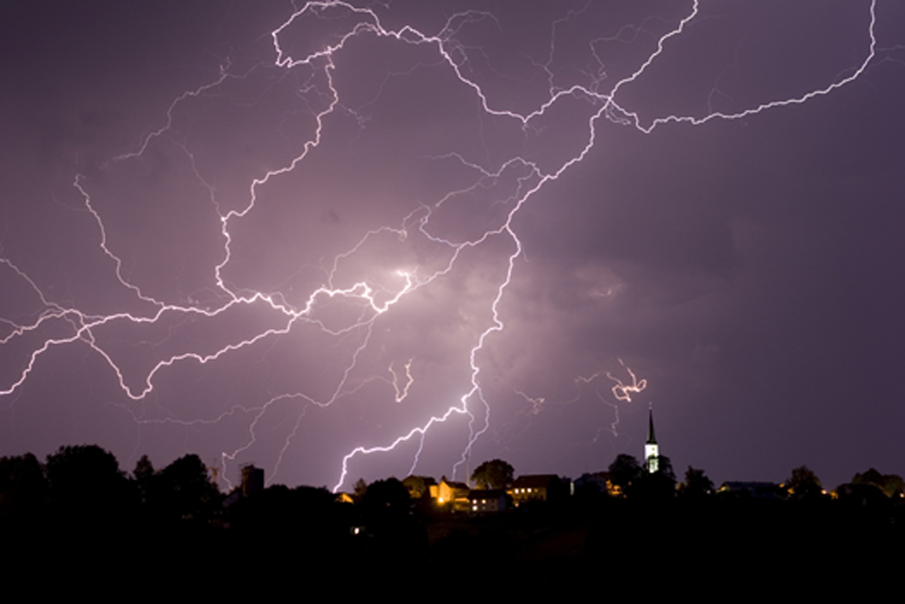
SIGN UP TO THE
BRANCH FUNDS INITIATIVE
FOR EXCELLENT
INTEREST RATES
3.05%
in the met!

Do you have something to say?
Has something happened in your county or branch that you would like to share with the rest of the London Met Region?
Do you have an event coming up that you would like published?
Let Louis know!



DATES FOR THE DIARY
Thursday 27th & Friday 28th October – Poppy Appeal Launch
Thursday 3rd November – City of London Poppy Day, contact the londonpoppyappeal@britishlegion.org.uk for more details
Thursday 10th November – The Battle of Park Lane, The Army Boxing Team v London Amateur Boxing Association. Tickets and further information on 0208 704 4141, teamarmy@fireball.co.uk, www.freball.co.uk
Friday 11th November – Armistice Day
Saturday 12th November – Festival of Remembrance
Sunday 13th November – Remembrance Sunday
Tuesday 13th & Wednesday 14th December – Christmas celebrations at the Guildhall, London. Contact Rebecca Pride, 0203 207 2272 or rpride@britishlegion.org.uk

